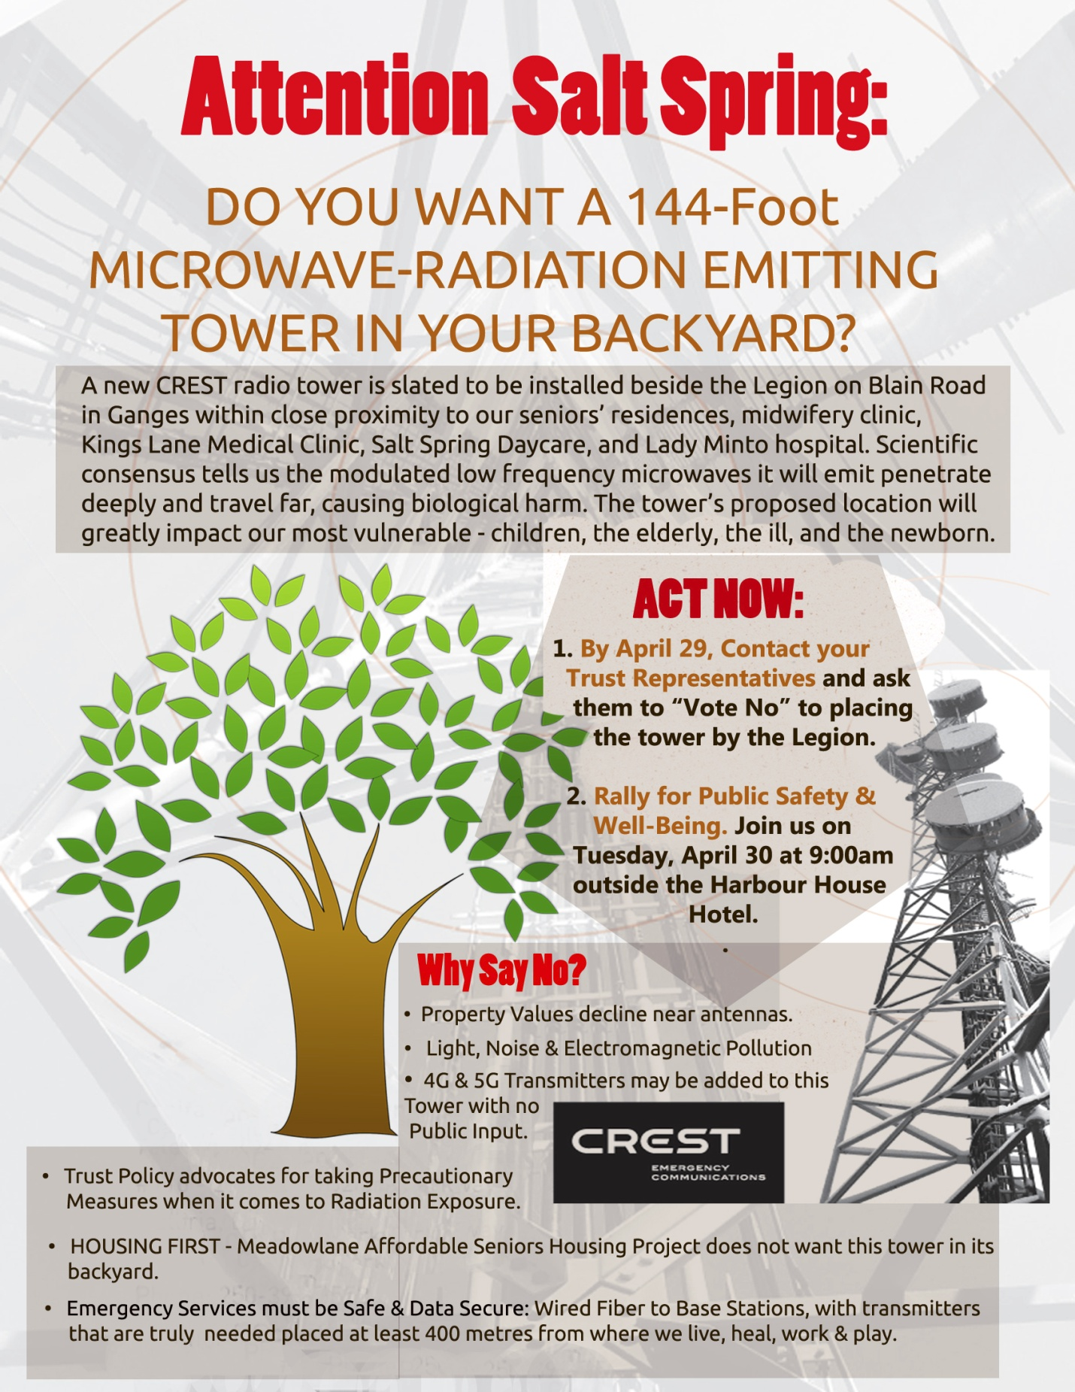

- Low Frequency, Big Impact. The CREST radio tower project is slated to be installed beside the Legion on Blain Road in Ganges. This radio tower will transmit modulated radio frequency waves in the 132–174 MHz range. These low microwave frequencies pose a greater concern than 5G’s millimeter waves because they can penetrate just about anything deeply, and the lower frequencies are more biologically active when they are modulated. Expert peer-reviewed science overwhelmingly links exposure to radio frequency radiation to significant cellular and DNA disruption in humans and all living species, resulting in cancer, heart and developmental diseases, autism and more.

- If you build it, they will come. If this tower is permitted, federal policy allows the Legion to enter into co-location agreements with telecoms without further consultation with the Islands Trust or the public, allowing them to place 4G and 5G transmitters on this same site. While additional lease agreements may earn the Legion another $12,000 to $30,000 a year per transmitter, they also increase the public’s exposure to radio-frequency radiation.

- Does this Project have the Public Interest at Heart? Karl Reardon, the Engineer the CRD hired to do the project’s Safety Exposure test is not an “independent consultant” as required by the Salt Spring Islands Trust’s electromagnetic radiation exposure policy. The company he works for, Planetworks, is heavily vested in promoting and advocating for wireless communication systems and Karl Reardon who formerly worked as General Manager and Product Developer for Motorola holds six US patents on wireless data technologies.

- Aesthetic Blight - Light & Noise Pollution. CREST chose the Legion site because it is one of the highest available points in Ganges. The higher the antenna is placed, the further the radio can transmit and receive. The proposed tower will be 144 feet tall with LED lights on the top and in its middle and will have noisy cooling fans running 24-7.

- Property Values decline near radio-frequency tower sites.

- The gap in emergency service coverage CREST claims this project is filling is the Ganges Marina and Ganges Harbour area, but the modulated low frequency waves this system will employ can travel for 40 or more miles. This is a very big tower and given its close proximity to Greenwoods, Braehaven, Meadowbrook, Heritage Place, Kings Lane Medical Center and its new midwifery clinic, and Lady Minto Hospital, its proposed location will greatly impact our island's most vulnerable - the elderly, the ill, and the newborn, all for the need to improve coverage in a very small area.
- Housing First! The project has been opposed by the Gulf Islands Seniors Residence Association, an organization planning to build a much-needed 48-unit senior's affordable housing complex called Meadowlane, which would be directly kitty corner to and about 20-40 metres from the tower.
- First People's Input Required. The land adjacent to the site is on a former Cowichan Village site. The proposed tower location may also be a part of this same Cowichan Village site. If that is the case, the Cowichan Tribe must be consulted about an archaeological review.

- Want Safe, Secure Data? Get Wired! Wired Fiber networks provide the fastest, safest, most data secure way to transmit information and provide emergency services. As reported in this Wall Street Journal article, https://blogs.wsj.com/digits/2011/08/10/security-flaws-in-feds-radios-make-for-easy-eavesdropping/, researchers from the University of Pennsylvania found major security flaws in the P25 systems CREST is installing. Not only did researchers overhear conversations that included descriptions of undercover agents and confidential informants, they effectively jammed signals using a child’s electronic toy. Our current legacy system may be adequate. If the rest of the CRD is moving to a phase 2 P25 system, their phase 2 radios will be backwards compatible with analog FM modulation.

