https://webcache.googleusercontent.com/search?q=cache%3AptZFrA3qewcJ%3Ahttps%3A%2F%2Felectronics360.globalspec.com%2Farticle%2F15299%2F5g-and-its-effects-on-human-health&fbclid=IwAR0EKv7dOs6ucKjnyUmVvb42srdzI-iPQo799FAEswsiDwFvhEL2fr4_4TY

HOME INDUSTRIES TELECOMMUNICATIONS MOBILE DEVICES ARTICLE
Share
Mobile Devices

5G and its effects on human health
Abbas Haider
18 June 2020

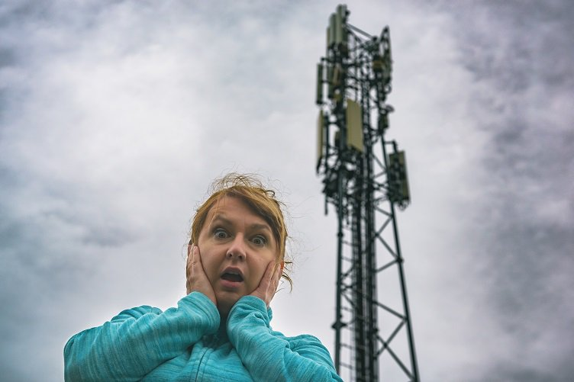
What are the health risks of 5G? Source: AdobeStock
There has been a lot of discussions surrounding 5G technology for the past few years, but the process of rolling out the new standard of wireless has already begun earlier this year from carriers such as AT&T, Sprint and Verizon. However, there is still a year or more before 5G is widely available and it will only be rolled out in a few cities this year.
Yet, it is not stopping device manufacturers and service providers from 5G bandwagon usage. Mobile manufacturing companies are designing new devices with 5G compatibility. Before getting into the details of 5G and its effects on human health, read on for an explanation about what 5G is.
What is 5G?
In simple terms, 5G is the fifth generation of mobile technology that boasts faster internet browsing, streaming, download and upload speeds, and better connectivity as well.
Other than the fast streaming of the latest movies and videos, 5G also facilitates increased capacity and reduced latency. Latency can be defined as the time taken by the network for device communication with other devices.
Likewise, 5G technology plays a very important role in many integrated applications, for instance, robotics, automated and self-driving cars, and various medical devices.
The 5G technology will be based on the use of bandwidths with higher frequencies. In terms of network performance, the improvement is at least 10 fold. The peak speed of 4G is approximately 50 Mbps. But it is anticipated that 5G will deliver peak speeds ranging from 10 Gbps to 20 Gbps. Network latency will be improved to 1 ms from 30 ms, which is considered ideal for streaming games, online videos, movies and the internet of things (IoT).
In order to cover all the railways and major roadways of urban areas with the uninterrupted wireless communication of the fifth generation technology, a significant network of antennas and transmitters has emerged. In other words, the number of base stations of higher frequency and other devices will increase considerably, which gives rise to the question of whether 5G technology has a negative impact on human health and its surroundings due to these higher bandwidths and numerous other connections. To better understand the effects of 5G on human health, read on for more on 5G technology and the millimeter-wave technology on which 5G is based.
5G technology and millimeter-wave
One of the main characteristics of 5G technology is the use of millimeter waves. In the case of 4G technology, radio waves are used to broadcast data. However, the radio wave spectrum is already jam-packed with signals. That is why there is a need for a whole new spectrum for 5G technology, which allows more traffic. To better understand it, imagine the construction of a second highway when the first highway becomes overcrowded with cars.
Named for the much shorter wavelength of radio waves, millimeter waves are only 1 mm to 10 mm in length. Because of their shorter wavelengths, millimeter waves have a higher frequency, which implies that they can transmit more energy.
As far as the effect on the human body, millimeter waves are reportedly more likely to be absorbed within a couple of millimeters in the skin. Since there have been no previous consumer applications of millimeter waves, there is little scientific data about its impact on human health. However, limited data about millimeter waves has shown that it can affect the peripheral nervous system, immune system and the cardiovascular system, even with the short-term exposure.
Effects of 5G technology on human health
Cancer and tumors
Studies have shown that cell phones, Wi-Fi and other wireless technologies can cause cancer and tumors. The findings are the same for wireless 5G technology. In fact, it is more hazardous as it uses millimeter waves with higher frequencies.
Electrohypersensitivity (EHS)
Electrohypersensitivity can be defined as a series of syndromes, named idiopathic environmental tolerance, or also known as medically unexplainable symptoms that cause some people to experience the symptoms of fatigue, severe headache, weakness, sleep disorder, memory impairment or a general feeling of illness. Some people tend to develop EHS when they are exposed to high-frequency waves. So, concerns are that 5G technology might cause EHS as researches have shown that it has been caused by the use of regular cell phones.
Children and radiational absorption
Researches have shown that children are more prone to absorb micro radiations because their brain tissue is reportedly more absorbent, their brains are relatively smaller than adults and their skulls are thinner. It might take years to discover the true health consequences among children, but there are also many other reasons why children are at greater risk. One of the reasons is that their bodies and brains are immature and still in the development phase.
So, with regards to the impacts of 5G technology on children, the main cause for concern is heightened exposure. As in the presence of 5G technology, there is a high possibility that children might be exposed to RF radiations all the time, at home, at school, or even in the parks and streets
Skin amplifies human health risks
One of the health risks of 5G technology is how EMF radiations react with the human body. When human sweat ducts have been exposd to millimeter waves, studies have shown that they act as an array of small antennas in the shape of a helix. This suggests that these millimeter waves are not only absorbed by the human skin, but are actually amplified by human skin.
5G, DNA damage and the future of the human genome
Another important concern about the effect of 5G technology on human health is its effect on DNA. In the presence of 5G technology, there are greater chances of DNA damage. Damage to DNA could cause serious consequences on the human genome future. According to studies, breakage of DNA strands in living cells can be caused by exposure to both pulsed and continuous RF radiation. The stored information in these DNA cells becomes corrupted.
To contact the author of this article, email engineering360editors@ieeeglobalspec.com

