5G National Rally
Salmon Arm
Wed., May 15th at Ross Street Plaza
11:45 am - 1:15 pm
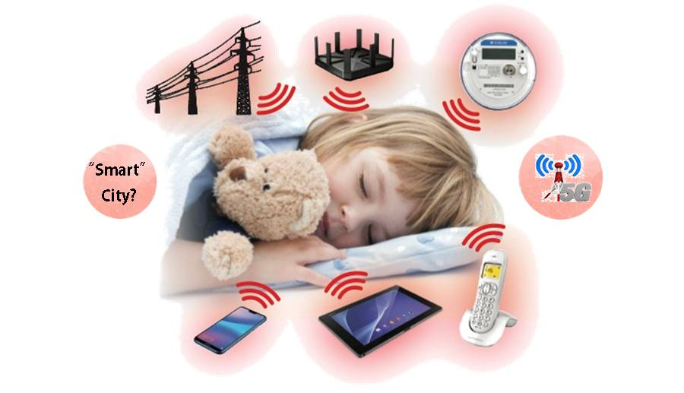
ARE THEY SAFE.?

WIRELESS TECHNOLOGIES, SMART METER RADIATION, ELECTRIC AND
MAGNETIC FIELDS, DIRTY ELECTICITY,
+ 5G MICRO CELLS/SMALL CELLS
EVERY 2 TO 8 BUILDINGS ALONG OUR STREETS!

PLUS 6 CELL ANTENNAE PROPOSED FOR SALMON ARM
CITY CENTRE - ALEXANDER STREET

IS THIS WHAT WE TRULY WANT?
COME! ASK! LEARN!
(Bring a poster if you can!)

SPEAKERS, Dr. Ross Andersen, Capt. Jerry Flynn HANDOUTS AND MORE

WEBSITES: BOOKS:

www.EHTrust.org fb ParentsForSafeSchools “Hidden Dangers” by Jerry Flynn
www.stopsmartmetersbc.com “Dirty Electricity” by Sam Milham MD, MPH

