A Response to BC’s Ministry of Citizens’ Services Decision on Resolution B100
2017 Resolution B100 Microcell Transmitter Placement Consultation
Endorsed by the UBCM

Whereas public consultation on the placement of cell towers is mandated;
And whereas new technology is moving away from these large towers to microtransmitters which do not require local government or public consultation:
Therefore be it resolved that the UBCM petition relevant provincial and federal governments to mandate consultation with the land use authorities and the public regarding microcell transmitter siting within 100 meters of residences, schools and hospitals.
Overview
Resolution B100 addresses the placement of microcells, which are small cell towers, by residences, homes and schools. Unlike freestanding macro cell antennae, microcells are typically mounted on existing structures like hydro poles and lampposts in the public rights-of-way. Along with the antenna, a microcell installation may also include refrigerator–sized cabinets containing power supply units and noisy cooling equipment.
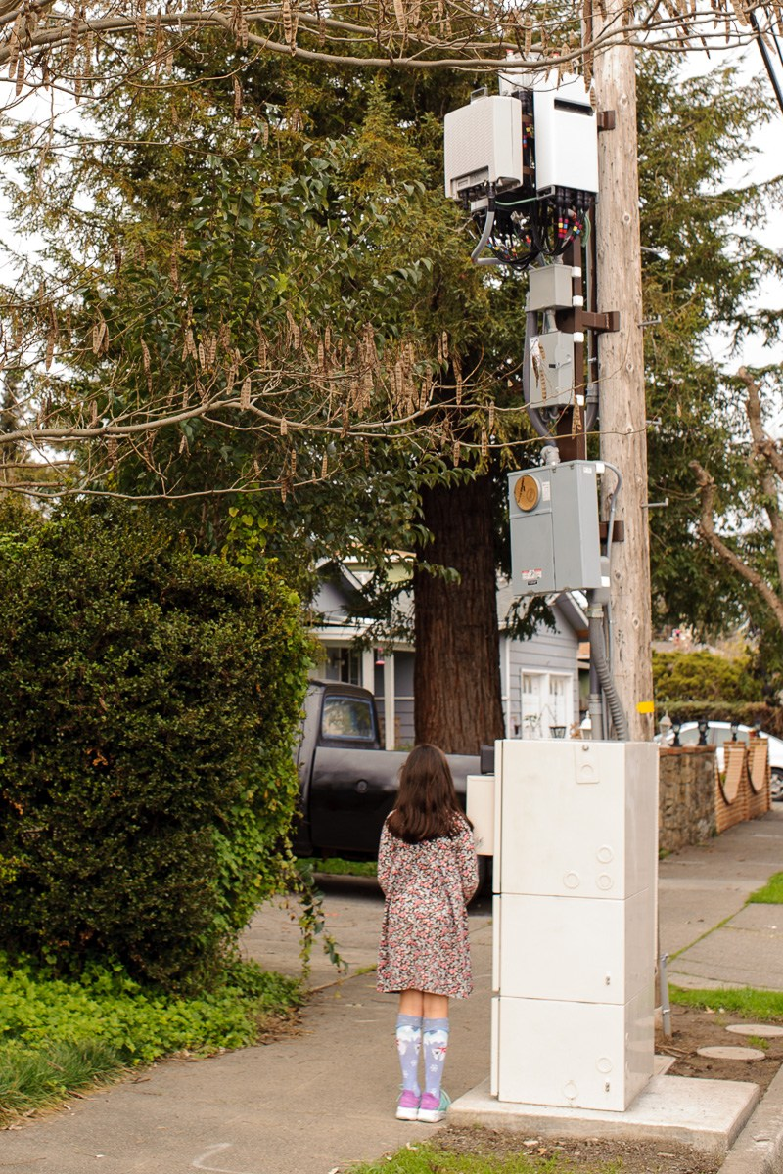
Microcell Installation in Santa Rosa, California
While microcells are currently being used for 4G cellular service, small cell densification is underway in preparation for the rollout of 5th Generation – or 5G – technologies. 4G transmits microwave frequencies, but 5G employs millimetre waves that travel short distances only and are absorbed by buildings, trees, and bodies. In order for 5G frequencies to penetrate every home, they must be placed close to residences, with each carrier deploying between 2-10 small cell towers per street.
Although the biological effects of 5G communication systems have scarcely been investigated, the rollout of 5G has begun. Initial scientific studies have found exposure to millimeter waves promotes oxidative stress - a condition involved in cancer onset - acute ocular injuries, and more. Current Canadian federal policies permit microcells, which will transmit 5G, to be installed on existing structures by homes, schools and hospitals without consultation with land use authorities or the public.
A Point-by-Point Analysis of the Province’s Response to Resolution B100 on Microcell Placement
Point 1:
The Province:
Point 1: Demand for cellular service is growing, and is expected to continue as more and more British Columbians use smartphones and other mobile devices.
Response:
Point 1: Demand for Mobile Cellular Service is declining.
While three quarters of Canadians ages 15 and older own smartphones, mobile use of smartphones is declining.
Catalyst Canada, a social marketing agency that conducts annual surveys measuring Canadian smartphone adoption and behaviour, reports that while at-home smartphone usage has risen, on-the-go activity has declined. They attribute this decline to data limits imposed by cell phone providers, stating that: “People might be conducting more activities at home in part because they are usually connected to Wi-Fi.” In their 2017 Canadian Mobile Survey, Catalyst found that 50% of respondents were likely to list security concerns as a primary reason for shying away from performing monetary tasks or sharing information on their phones.
Point 2:
The Province:
Point 2: To accommodate this demand, more towers will be needed.
Response:
Point 2: Although need is subjective, existing Cell Towers are Sufficient, while wired Fiber Optics Offer the Fastest Data Available.
4G and 5G wireless networks depend upon fiber optic cables to transmit data. Connecting fiber optic directly to each premise instead of using microcells to beam signals wirelessly creates the safest, fastest communications infrastructure in existence.
- Wired fiber optic networks are always faster and more data secure than wired ones: “It is the ideal situation to have a wired link. (It is) more reliable in many ways and far more secure.” - Elizabeth May
- Most Canadian smartphone users are choosing to use their phones at home rather than with their data plans, on the go. For greatly increased data speed, security, and reduced exposure to radiofrequency radiation, smartphones and tablets used at home, work, or school may be connected to wired networks via ‘lightning to ethernet’ adaptors.
- Canada excels in both 4G speed and availability. Existing cell towers are enough. In their 2017 report, State of Mobile Networks: Canada, OpenSignal, a company that specializes in global wireless coverage mapping, stated, “With nearly 80% LTE availability and speeds pushing 30 Mbps, Canada...is in the top tier of global 4G performance.”

What is really Behind the Push for Microcells?
The wireless industry claims densification of small cells is needed to enable innovations such as smart cities and the Internet of Things (IoT), but we can achieve most IoT and smart city functions without microcells.
Mobile industry giant Ericcson reports that by 2021, 95% of mobile data traffic will consist of people using their smartphones to watch videos. Small cell densification is more about paid consumer and commercial video than it is about smart cities.
Industry analyst Bruce Kushnick states that telecom providers are installing microcells to “’shut off’ the retail wires and force-march customers onto more expensive wireless.” Despite the ultrafast data speeds promised by 5G, he states that current cell phone pricing and data allotments are inadequate to watch HD movies using a smartphone, especially if the phone is tethered to a large screen. While telecom providers can make more from selling us cell phone data plans than they can from selling wired television, phone, and internet subscriptions, it is unlikely 4G or 5G wireless networks will adequately meet consumers’ evolving needs.
Point 3:
The Province:
Point 3: The Government of Canada regulates tower siting decisions, settles disputes, and sets health and safety standards. The federal department of Industry, (sic) Science and Economic Development (sic) (ISED) Antenna Siting Procedures (sic) have recently been updated and require cellular providers to work even more closely with local communities.
Response:
Point 3: It is Time to Close the Microcell Loophole.
- The federal department of Innovation (not Industry), Science and Economic Development Canada (ISED) regulates towering siting in Canada.
- In April 2014 - 4 years ago, which in the fast-paced world of tech development does not qualify as “recent” – changes in relation to tower height were made to the federal government’s Antenna Siting Procedures, but antennas placed on existing structures, like microcells, were not addressed, and were left exempt from public consultation. In a statement made on the day the changes to Canada's Antenna Siting Procedures were announced, Claude Dauphin, then President of the Federation of Canadian Municipalities (FCM) said:
“(The) FCM has been calling on the federal government to close a major loophole that permitted wireless companies to build antenna towers under 15 metres without notifying or consulting affected communities. The changes announced today respond directly to our call.
We commend the government on its decision to update Canada's Antenna Tower Siting Policy, and for expanding the role of municipalities and the public in providing meaningful input on the siting of antenna towers in our cities and communities. This provides further proof of what we can accomplish when all orders of government and the private sector work together as partners to meet the needs of our communities."
- Resolution B100 asks the provincial and federal government to now work together to close the existing microcell placement loophole, giving communities the same meaningful input that has been granted for antenna towers that are under 15 metres in height.

- In 2012, the UBCM membership endorsed Resolution B141, which made this same request in more general terms. This Resolution called on the federal government to institute a requirement for consultation with local governments prior to approval and installation of telecommunications towers or antennae.
Point 4:
The Province:
Point 4: Cellular providers must share towers where possible, consult with local governments and the public regardless of tower height and type, and adhere to Antenna Siting Procedures. More information can be found at this link: http://www.ic.gc.ca/eic/site/smt-gst.nsf/eng/sf10840.html
Response:
Point 4: Cellular Providers do not need to consult with the public about Microcells.
- Because microcells are deemed Excluded Antenna Structures by ISED, local governments are not permitted to include a public consultation requirement for them in the Antenna Siting Procedures they create. The ISED document the Ministry of Citizens’ Services has linked to above confirms this:
48. The following proposals are excluded from land-use authority and public consultation requirements:
- Non-Tower Structures: antennas on buildings, water towers, lamp posts, etc. may be excluded from consultation provided that the height above ground of the non-tower structure, exclusive of appurtenances, is not increased by more than 25%
62. Proponents must always contact the applicable land-use authorities to determine the local consultation requirements and to discuss local preferences regarding antenna system siting and/or design, unless their proposal falls within the exclusion criteria outlined in Section 6.
- Section 3.2 of the Guide to Assist Land-use Authorities in Developing Antenna System Siting Protocols, published by Industry Canada in August 2014, affirms that Canadian land use authorities do not have the right to override the exclusions to public consultation established by ISED. The quote below, taken from this document also reveals that in 2014, the federal government did not comprehend, or did not want to acknowledge, the significant impact the densification of small cells and emerging 5G technologies would have on communities, on residents, and on society. (Do a web-search on 5G, SB 649, or small cells and local authority, and it is clear this issue is not one of “minimal impact.”):

Section 3.2: Excluded Antenna Structures
“Under Industry Canada’s process, certain proposals are considered to have minimal impact on the local surroundings and so are excluded from public and land-use consultations. Industry Canada believes that consultation requirements should be proportional to the potential impact of the proposal... It should be noted that any exclusion criteria established by the LUA can only augment, as appropriate, those established under Industry Canada’s Exclusion List (CPC-2-0-03, Section 6).”
Point 5:
The Province:
Point 5: Communities and local governments are best positioned to work with cellular providers to ensure effective delivery of services, while also ensuring respect for local land-use considerations.
Response:
Point 5: Communities and local governments have little, to no, leverage with cellular providers when it comes to deciding if microcells will be installed.
- Local governments may use the Antenna System Siting Protocol Template created by the FCM and the Canadian Wireless Telecommunications Association (CWTA) as a model for creating their own antenna siting protocols. Local protocols may request that municipalities be notified when exempt antenna structures are to be installed, and may also state design and siting preferences for microcells, but once a land use authority (LUA) gives its permission for microcells to be installed, cellular providers have the final say in where they are placed.
- Cellular providers are not required to be responsive to residents who do not want small cell towers placed in front of their homes. Residents’ concerns may include public and environmental health, data safety, national security, infringement upon their use and enjoyment of the public rights-of-way, or decreased property values.
- Local governments may not issue a statement of non-concurrence based on the community’s response to having microcells installed on their streets.

The Province:
Point 6: ISED Staff are available to assist municipalities in understanding their role and to provide advice.
Response:
Point 6: Seeking Assistance from ISED - The Bigger Picture

In the Exclusions section of their 2014 Decision on Amendments to Industry Canada's Antenna Tower Siting Procedures , ISED admits to regulatory challenges when it comes to excluded antenna structures. Point 43 of this document says: “Although CWTA members have agreed to consult on "excluded" antenna system proposals where required by the municipalities, Industry Canada notes that not all commercial operators are members of the CWTA.”
- Telus and Shaw, two of the largest wireless providers in BC are not CWTA members.
- CWTA is, however, the administrator of the 5G Canada Council, a group whose mandate is to “encourage a supportive and dynamic 5G ecosystem in Canada, including the efficient rollout of related technologies. “
- The chair of the 5G Council is Scott Bradley, VP Corporate Affairs of Huawei, Canada, the multinational leading the global 5G charge. Telus and Huawei have created a "living lab" in Vancouver where they are testing their planned rollout of 5G in Vancouver and Telus is already using 4G microcells manufactured by Huawei across BC to gather and transmit our data.
- In March 2018, six top US security chiefs, including directors of the CIA, FBI, and the NSA, warned that Huawei has shared sensitive information with China, and that Huawei’s equipment and the new 5G technology provide China with the capacity to conduct remote spying and maliciously modify or steal information or even shut down systems. They do not recommend private citizens use products made by Huawei. Three former directors of Canada’s key national security agencies are urging the federal government to heed the warnings of U.S. intelligence services and cut Canadian ties with Huawei. Ward Elcock, a former CSIS director, deputy minister of National Defence, and Security and Intelligence Deputy Clerk of the Privy Council, said, “I would not want to see Huawei equipment being incorporated into a 5G network in Canada.”
In Closing
The race for 5G is on, and the speedy densification of microcells is essential to it. On March 19, 2018, Innovation Minister Navdeep Bains announced the federal government is giving millions of dollars to an industry cohort headed by mobile tech giant Ericcson to help fund the rollout of 5G in Canada. He also addressed concerns raised by wireless carriers about barriers to installing the hundreds of thousands more small-cell sites needed for 5G.
"We have been very clear that we want to have a robust [approval] process, a process that defends the public interest, but at the same time encourages more innovation and more investment," Mr. Bains said. "We're willing to work with the carriers to look at where we can reduce and eliminate any process or timelines that exist that prevent those investments from happening."
While it is clear the tech and telecommunications sectors plan to profit from the masses of 5G transmitters and devices they will make, sell, install, and operate, the benefits of 5G to the rest of us are dubious, at best. (When key industry players attending the 2018 Mobile World Congress discussed whether 5G will deliver on its promises, Samsung’s Head of Research Dan Warren said, “You need to have small cells everywhere. You need to have cells where they do not go now.” )
Meanwhile, scientists worldwide warn of the potential serious health implications of 5G. Although Health Canada is the body officially responsible for protecting Canadians from the health effects of microwave and millimeter wave radiations, the standards developed by Health Canada and their neutrality in reaching these guidelines have long been called into question.
Municipal and provincial officials, along with federations of municipalities like the UBCM and the FCM, have a mandate to preserve and protect, and to advocate on behalf of citizens by bringing issues that have a direct impact on local communities to Ottawa. Sidestepping this responsibility by deferring to a safety code that many reputable scientists say is inadequate places the well-being of their constituents in peril.
In 1998, Canada adopted the Wingspread Precautionary Principle, which states:
“When an activity raises threats of harm to human health or the environment, precautionary measures should be taken, even if some cause and effect relationships are not fully established scientifically.”
Rethinking the indiscriminate installation of microcells in our communities supports this principle, and preserves and protects the well-being of all.

Di Ciaula A, “Towards 5G communication systems: Are there health implications?”, Int J Hyg Environ Health. 2018 Feb 2. pii: S1438-4639(17)30814-3. doi: 10.1016/j.ijheh.2018.01.011. [Epub ahead of print], https://www.ncbi.nlm.nih.gov/pubmed/29402696
“With Growth comes Change: The Evolving Mobile landscape in 2015”, http://catalyst.ca/2015-canadian-smartphone-market/
“Canadian Smartphone Behavior in 2017: Continued Shift to Virtual Spaces”, http://catalyst.ca/2017-canadian-smartphone-behaviour/
“Wired vs Wi-Fi speed”, Verizon Communications, https://www.verizon.com/cs/groups/public/documents/adacct/wires-vs-wifi-speeds.pdf
“With Growth comes Change: The Evolving Mobile landscape in 2015”, http://catalyst.ca/2015-canadian-smartphone-market/
“Air Gap Technology: Hardwiring your iPhone or iPad”, https://www.wirelesseducation.org/hardwiring-your-iphone-or-ipad/
Open Signal, “State of Mobile Networks: Canada”, January 2017, https://opensignal.com/reports/2017/01/canada/state-of-the-mobile-network
Timothy Schoechle, PhD, “Re-inventing Wires: The Future of Landlines and Networks”, (National Institute for Science, Law and Public Policy, Washington, DC, 2018) http://electromagnetichealth.org/wp-content/uploads/2018/02/ReInventing-Wires-1-25-18.pdf
Ken Schmidt, “Top 10 Things the Wireless Industry Doesn’t Tell You About Small Cells”, April 11, 2017, Steel in The Air, http://www.steelintheair.com/Blog/2017/04/top-10-things-the-wireless-industry-doesnt-tell-you-about-small-cells.html
Bruce Kushnick, “Wireless Smartphones with Only 10Mbps Down, 1Mbps Up, are Not a Substitute for a Wired Broadband Connection”, HuffPost, October 19, 2019, https://www.huffingtonpost.com/entry/59e8ecbce4b0542ce4290c1c
“Statement by FCM President on Changes to Canada’s Antenna Siting Policy” (05/02/2014), https://fcm.ca/home/media/news-and-commentary/2014/statement-by-fcm-president-on-changes-to-canadas-antenna-siting-policy.htm
“DGSO-002-14 — Decision on Amendments to Industry Canada's Antenna Tower Siting Procedures”, Posted on Industry Canada website: June 26, 2014, http://www.ic.gc.ca/eic/site/smt-gst.nsf/eng/sf10840.html
Industry Canada, “Guide to Assist Land-use Authorities in Developing Antenna System Siting Protocols”, issue 2, August 2014, https://www.ic.gc.ca/eic/site/smt-gst.nsf/vwapj/LUA-e.pdf/$file/LUA-e.pdf
FCM & CWTA Joint Protocol,”Antenna System Siting Protocol Template”, Revised December 2014,https://fcm.ca/Documents/reports/FCM/Antenna_System_Siting_Protocol_Template_EN.pdf
“DGSO-002-14 — Decision on Amendments to Industry Canada's Antenna Tower Siting Procedures”, Posted on Industry Canada website: June 26, 2014, http://www.ic.gc.ca/eic/site/smt-gst.nsf/eng/sf10840.html
Learn more about the 5G Canada Council on CWTA’s website: https://www.cwta.ca/5gcc/
“Huawei announces 5G trial in Vancouver”, ZDNet, February 13, 2018 http://www.zdnet.com/article/huawei-announces-5g-trial-in-vancouver/#ftag=RSSbaffb68
Sara Salinas, “Six top US intelligence chiefs caution against buying Huawei phones”, CNBC, February 13, 2018, https://www.cnbc.com/2018/02/13/chinas-hauwei-top-us-intelligence-chiefs-caution-americans-away.html
Robert Fife and Steven Chase, “Former top Canadian security officials warn Ottawa to sever links with China’s Huawei,” The Globe and Mail, March 19, 2018, https://www.theglobeandmail.com/politics/article-former-top-canadian-security-officials-join-call-for-ottawa-to-nix/
Christine Dobby, “Feds, Ontario and Quebec to invest $200-million in linked network of 5G research labs,” The Globe and Mail, March 19, 2018, https://www.theglobeandmail.com/report-on-business/ottawa-ontario-and-quebec-to-invest-200-million-in-linked-network-of-5g-research-labs/article38299191/
Ryan Daws, “Delivering on 5G’s Promises,” Telecoms, March 2, 2018, https://www.telecomstechnews.com/news/2018/mar/02/editorial-delivering-5g-promises/
“5G Technology Reality Check: Can We Deliver On Our Promises?,” Mobile World Congress, February 27, 2018, https://www.mobileworldcongress.com/session/5g-technology-reality-check-can-we-deliver-on-our-promises/
Rainer Nyberg and Lennart Hardell, “Scientists and Doctors Warn of Potential Serious Health Impacts of Fifth Generation 5G Wireless Technology”, Global Research, September 2017, https://www.globalresearch.ca/scientists-and-doctors-warn-of-potential-serious-health-impacts-of-fifth-generation-5g-wireless-technology/5609503
Paul Christopher Webster, “Scientists decry Canada’s outdated Wi-Fi safety rules”, Canadian Medical Association Journal (CMAJ) , May 11, 2015 ,http://www.cmaj.ca/content/cmaj/early/2015/05/11/cmaj.109-5061.full.pdf
Declaration: Scientists call for Protection from Radiofrequency Radiation Exposure http://www.c4st.org/images/documents/hc-resolutions/scientific-declaration-to-health-canada-english.pdf
This statement arose from the Wingspread Conference on the Precautionary Principle, which took place in Wisconsin in January 1998.

