Timeline Photos
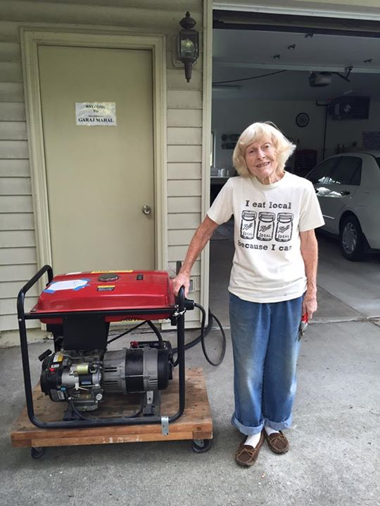

Andrea McNinch

When is it going to stop? I spent most of my day yesterday cleaning up DTE Energy's latest assault. This time on an 85-year-old woman for refusing a smart meter!!
They actually brought 2 police officers! Why? To make sure there was "no trouble." Take a look at this pic? They terrorized a grandma!! I have stayed pretty silent on social about what has been going on, but I am disgusted what they did to this poor woman in Auburn Hills - this is just AWFUL! I am not showing this to put fear into any of you about refusing a smart meter, this is what they want. She was attacked like me for standing-up (6 days after I packed the Main Art Theatre and showed Take Back Your Power), as her husband is a major advocate and is working on getting a bill passed for meter choice here in Michigan. She was retaliated against and they came when her partner was out of town. I don't think that's a coincidence - more like strategy. He was actually on the west side of the state "flyering" to spread awareness about the upcoming house bill. He was also in negotiations with AMI manager Joseph McCormick about keeping his analog. DTE actually tricked poor Glenna and cut her from the pole. The letter they left with their claim/ demand was not what they told her when they showed-up. These people are ruthless and will even manipulate and lie to an 85-year-old woman. And shame on those police officers for being part of an assault on an 85-year-old!
Please share. Don't be scared. That's what they want. We need the public to know what's going on behind the scenes. It's CRIMINAL! As far as the news media covering it, they are all in DTE's back pocket. Any stories they have ran make it seem like we have a choice and we don't. This is what they did to me. They sent a paid-for news crew to my home. Aired a story that said I committed a felony and that I had meter choice (we don't the opt-out program is NOT a true opt out). So I am a nut-job criminal according to what they aired. The only way we can get the truth out there is through social. PLEASE, PLEASE, PLEASE help get this out far and wide: SHARE!
They literally attacked a helpless grandma...what's next??
PIC:
Got her hooked-up on a generator after some hard work. As you can see DTE couldn't take her smile!

